CPSC 2150 – 001  
Assignment 7 Jay Lee  
 100357736

**Formulae per loading:  
a = load factor**

**Linear Probing for successful search:  
**

**Linear Probing for unsuccessful search:**



**Quadratic Probing for successful search:**

**  
Quadratic Probing for unsuccessful search:**



**Results per loading:**

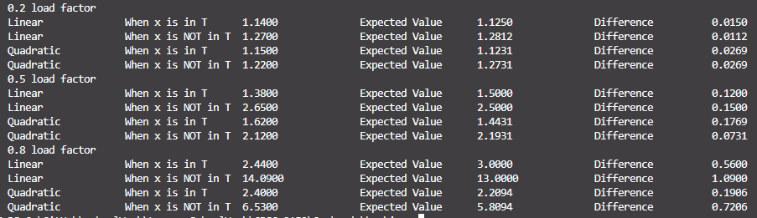

**Experiment Summary**

From the program results, quadratic probing is far more efficient compared to linear probing especially as the load factor nears 1. This could be because quadratic probing prevents elements from clustering up to a certain extent which decreases probing time.

Something noteworthy about the experiment is the difference between theoretical timing and empirical timing I got from the program. Although empirical values were quite relevant to the expected result, I was able to see trivial discrepancies between the two.

These discrepancies could have derived from the size of the hash table or the way that hashing is done, but leaning more towards the size of the table. Or it could be from lack of trials to eliminate the extremes.

Discrepancies can be coming from many different factors since out of the 100 trials, there could have been cases where elements in the hash tables are clustered and made probing go through more trials than expected.

Difference between empirical and theoretical results were less than 1 comparison with an exception of 1 case, and it had a tendency of growing larger as load factors increased.